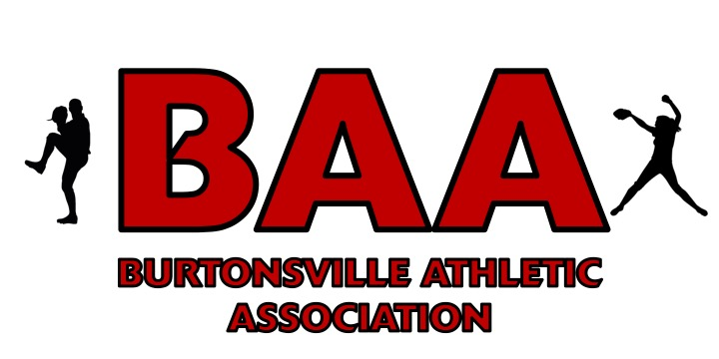
BAA COVID-19 Safety Protocols for 2021 Spring Season:
Updated February 8, 2021
We expect all Burtonsville Athletic Association participants to be aware of and abide by our league policy and Maryland Department of Health recommendations, including face covering mandates and travel advisories.
We ask that all BAA participants do your part to help keep our players, coaches, and community safe by following our safety protocols. League officials, our coaches, and/or the umpire have the authority to stop the game if protocols and/or state recommendations are not being followed. Everyone is also expected to follow all county regulations regarding field use, to ensure health of all and to make sure we are not breaking any rules.
Priorities
1. Hand Washing - We recommend you wash your hands often and that parents ensure that each player has a personal supply of hand sanitizer and wipes for themselves.
2. Social Distancing - Please maintain at least 6 feet between you and other families.
3. Face Coverings – Guests, coaches, and players should wear face coverings (preferably more than 1 layer). For players and coaches, this includes using face coverings at practice and during games and applies to all participants regardless of vaccination status until further notice. Participants may remove masks only when drinking and should be spaced at least 6 feet apart to do so, and when done replace their mask.
4. Cleaning & Disinfecting – Coaches, players, and parents alike should do their part. Hand sanitizer and disinfecting wipes will be available for each team. Coaches should do their part by cleaning and disinfecting commonly touched areas, cleaning (i.e., rinse) and disinfecting catching equipment in between practices and games and ensuring that players use personal equipment each practice and game. Parents can help do their part by keeping areas clean and disposing of trash. Players should do their part by bringing personal equipment and using proper hand hygiene.
5. Health Monitoring – Daily self-evaluated wellness screenings, including temperature measurement, need to be completed by all players/coaches/parents/guests prior to participating or attending any BAA sponsored activity.
a. Guests experiencing COVID-19 symptoms (fever, chills, cough, shortness of breath, etc.) should contact their health care provider immediately and the dedicated league official to follow the BAA action plan.
b. Anyone with direct exposure to a person that has tested positive for COVID-19 would need to self-quarantine and not attend/participate for 14 days.
Minimizing Frequently Touched areas:
- Please bring your own seating – Bring seating for your child. The bench will only sit a few players with social distancing. Bring a chair so that the “bench” can be extended.
- Have players bring their own personal water container, no sharing.
- When coaches handle bats, they should do so by grabbing the barrel of the bat.
- Minimize contact with the ball. Foul balls should not be handled by spectators. If this occurs, retire the ball from the practice or game.
Pre-Game:
· Coaches will serve as the lead safety officer for the team. Additionally each team will need a parent to serve as the safety monitor. We need at least one parent per team to manage the team in the dugout area. Ideally, more than one parent would volunteer so they can alternate responsibilities at games. This parent would make sure kids are social distancing, not touching or sharing other players equipment, etc. The parent support and participation is the only way we can make this season work.
- Carpooling is not recommended.
- Players should wait in the car or away from the field until designated arrival time to allow previous event to clear out and to prevent crowding.
- Pregame team meetings between umpire and coaches require social distancing of 6 feet.
- Baseballs will be designated to each team (not shared between innings) and wiped down frequently.
- Do not share equipment.
o Each player shall have their own glove, helmet and bat. If this provides a financial hardship, we will provide them for you for the duration of the season.
o Players should place their equipment along the fence or on the grass in a manner consistent with social distancing (separated by at least 6 feet).
o If equipment (such as catcher’s gear) is shared, an adult must properly clean (i.e., rinse) and disinfect equipment prior to the next participant’s use.
During the game:
- Dugouts will be expanded to include bleachers as necessary, and we ask for your cooperation in practicing social distancing. Players may wait/visit with their families when their team is batting or between innings. Limit players in the dugout to the greatest extent possible, through use of extended dugout (chairs brought from home) and grass areas. Given movement in the dugout area, these safety strategies do not remove the need to use face coverings in the dugout.
- No spitting, sunflower seeds, peanuts in the shell or gum.
- The umpire will be positioned at least 6 feet behind the pitcher to call pitches and base calls.\
- High-fiving, fist bumps, hugging, handshaking, etc. will not be allowed. We recognize that this may be difficult to stop so coaches must stress this often to their players.
- Coaches should be socially distant (6 ft) as much as practical and wear face coverings.
- Spectators should sit with members of their household only, and at least 6 ft apart from other groups
Post Game:
- Post game handshakes between teams are prohibited, we ask that teams stand in front of their respected dugouts and tip their caps to the opposing team and their fans.
- Post game team meetings are prohibited on the field of play.
- Sufficient time gaps will be scheduled between games in order to prevent interaction with arriving players for next game.
- Team snack is not permitted for the 2021 Spring Season.
As medical and governmental guidance change, BAA policies will continue to evolve. If COVID-19 cases in our community increase, it may be necessary to suspend league play. BAA intends to follow all federal, state and local guidelines regarding recreational activities. All updates will be communicated to the BAA community and posted on the BAA website.

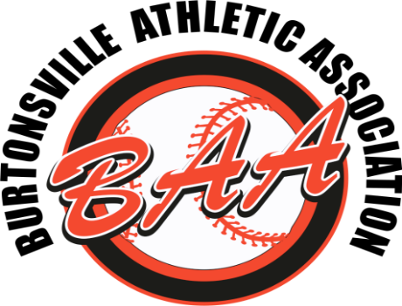

Burtonsville Athletic Association Plan of Action for COVID-19:
Watch for symptoms.
According to the Centers for Disease Control and Prevention (CDC), people with COVID-19 have had a wide range of symptoms reported – ranging from mild symptoms to severe illness.
Symptoms may appear 2-14 days after exposure to the virus. People with these symptoms may have COVID-19:
- Fever or chills
- Cough
- Shortness of breath or difficulty breathing
- Fatigue
- Muscle or body aches
- Headache
- New loss of taste or smell
- Sore throat
- Congestion or runny nose
- Nausea or vomiting
- Diarrhea
In the event a BAA athlete, coach, or official falls ill, we recommend the following steps:
- Daily self-evaluated wellness screenings, including temperature measurement, need to be completed by all players/coaches/parents/guests prior to participating or attending each baseball/softball activity.
- The athlete (via their parent), coach, or official should contact their physician to be evaluated.
- The most important tip for parents is to keep your child at home if they feel sick and/or any household contact has had symptoms consistent with COVID-19 or has tested positive.
- In the event that an athlete, coach, official, or player develops symptoms during a practice or game, the sick person should be isolated (6 feet distance maintained and mask worn by the symptomatic individual) while awaiting transportation to their home or to a health care facility.
- Contaminated equipment should be cleaned and disinfected by a coach using products that meet EPA disinfectant criteria and proper personal protective equipment (mask and eye protection, if available), followed by hand hygiene using hand sanitizer for 20 seconds.
- League official (eg. Coach) or any participant should notify the League Director of COVID-19 cases (including household contacts of BAA participants) for possible exposures, who will in turn notify the BAA Board and players and/or coaches involved.
- According to the CDC, community exposure is defined as when an individual has had close contact (< 6 feet) for ≥ 15 minutes with a person with COVID-19 who has symptoms or tests positive.
- BAA will not conduct official contact tracing; however, they will follow up with potentially exposed participants to communicate COVID-19 testing results (when known, in an anonymous manner) and Montgomery County Office of Public Health recommendations regarding risk assessment, isolation and quarantine recommendations.
- For exposures that meet the CDC definition of exposure, we will follow the isolation, and quarantine recommendations.
- For exposures that do not meet the CDC definition, BAA will err on the side of safety and reserves the right to suspend team, division or league activities in the interest of community safety for a duration consistent with CDC recommendations.
- Consistent with our approach during the BAA 2020 Fall season, players and teams potentially exposed shall not participate in events (practices or games) until such time that league officials in consultation with appropriate health agencies and BAA Board of Directors, have determined risk assessment and have finalized isolation and quarantine recommendations.
- In the event that practice and games are cancelled, the BAA League director (along with the coaches involved) will inform teams of cancellations.
- For an athlete, coach or official who tests positive for COVID-19, at a minimum, we will adhere to CDC recommendations before one is able to resume activities.
  - Presently, according to the CDC “for most persons with COVID-19 illness, isolation and precautions can generally be discontinued 10 days after symptom onset and resolution of fever for at least 24 hours, without the use of fever-reducing medications, and with improvement of other symptoms.” “For persons who never develop symptoms, isolation and other precautions can be discontinued 10 days after the date of their first positive RT-PCR test for SARS-CoV-2 RNA.”
- BAA participants will be expected to follow the Order of the Secretary of Health for Maryland about travel restrictions.
  - As of December 17, “The Secretary of Health (the “Secretary”) is hereby authorized and directed to issue orders under this Order requiring persons entering Maryland to quarantine and/or undergo testing for COVID-19, as the Secretary deems medically necessary and reasonable, for the purpose of monitoring, treating, preventing, reducing the spread of, and suppressing COVID-19 (“Travel Orders”).
· Throughout the season, as medical and governmental guidance changes, our Action Plan will continue to evolve. All updates will be communicated to BAA participants and posted on our website.

